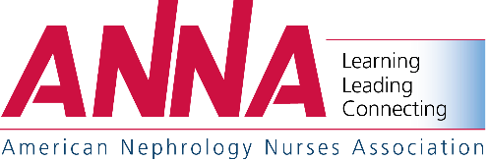
2020 National Symposium
April 19-22, 2020 – Orlando, Florida
Advance Registration Exhibit Personnel

Please Pre-Register Exhibit Personnel by March 16, 2020!

To facilitate your registration on-site, please register the names of company representatives who will be in attendance per the instructions below. As stated in the exhibit prospectus, each company is entitled to three (3) exhibit badges per booth or three (3) per 100 square feet. For additional badges over your allotment, the cost is $100 for each company representative.

NOTE –If you wish to provide registrations for nurses to attend the Symposium, you must complete the nurse registration application and submit the required registration fees. Companies may not register nurses for the $100 exhibitor fee.

Please complete and email this form to annabadge@ajj.com (Telephone – 856-256-2300).

Exhibiting Company Name |  | Booth #

Additional Booth Personnel – $100/Each
Representative | Email Address

Payment Information (ANNA Tax ID No. 23-7189008):

Payment by Check (Payable in US Funds) to:
ANNA National Symposium
Postal – Box 56, Pitman, NJ 08071-0056
UPS/Overnight Service – 200 East Holly Avenue, Sewell, NJ 08080

Full Payment by Credit Card:

Name on Credit Card
Credit Card Number
Expiration Date |  | Security Code
CC Billing Street No. |  | CC Billing Zip Code
Amount Authorized to Charge to Credit Card
Signature

